**Practical No -3**

**Design SQL queries for suitable database application using SQL DML statements: all types of Join, Sub-Query and View.**

**Create table-**

create table employee

(

empno number(5),

ename varchar2(20),

deptno number(5),

salary number(10)

);

--------------------------------------------

insert into employee values(101,'sanket',11,10000);

insert into employee values(102,'aniket',12,20000);

insert into employee values(103,'aditya',11,23000);

insert into employee values(104,'ani',13,450000);

insert into employee values(105,'yash',14,null);

insert into employee values(108,'mayur',12,33330);

------------------------------------------

select * from employee;

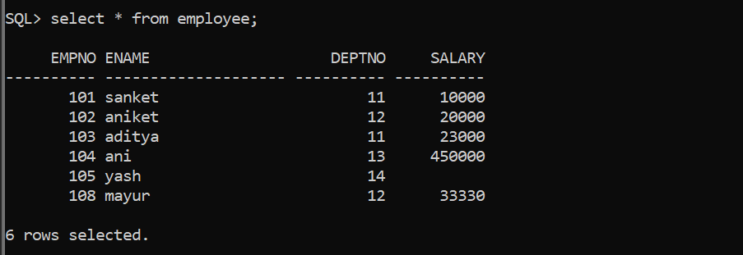

**Create table-**

create table dept

(

city varchar2(20),

pcode varchar2(20),

deptno number(5),

dname varchar2(20)

);

----------------------------------------

insert into dept values('pune','411005',11,'dev');

insert into dept values('mumbai','411005',12,'hr');

insert into dept values('gujrat','41235',17,'account');

insert into dept values('nashik','414449',14,'hr');

insert into dept values('ashik','00000',16,'hr');

--------------------------------------------------

select * from dept;

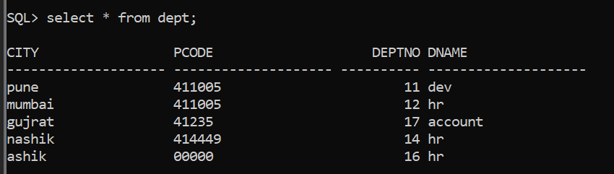

================================================

**INNER JOIN:- common records from both the tables**

select e.ename,e.deptno,d.dname from employee e,dept d where e.deptno=d.deptno;

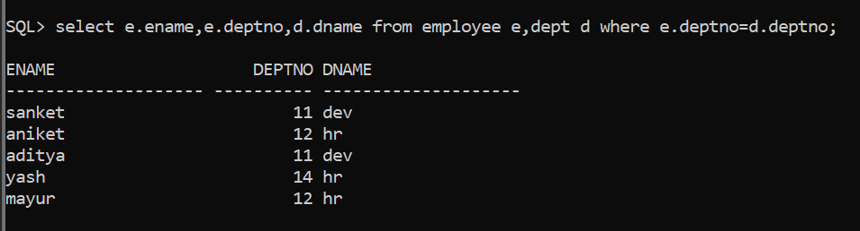

==============================================

**LEFT OUTER JOIN :-**

select e.ename ,e.deptno,d.dname,d.city from employee e left outer join

dept d on e.deptno=d.deptno;

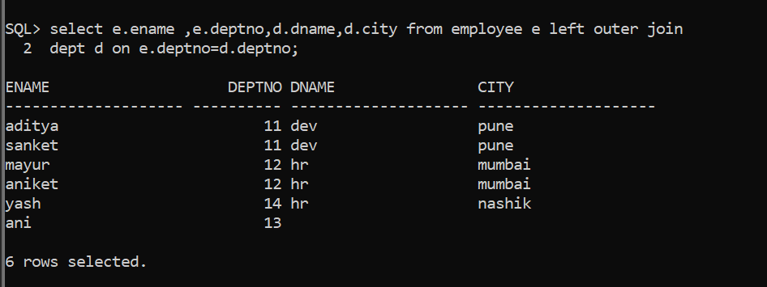

==================================================

**Right Outer Join:-**

select e.deptno ,d.dname,d.deptno from employee e right outer join

dept d on e.deptno=d.deptno;

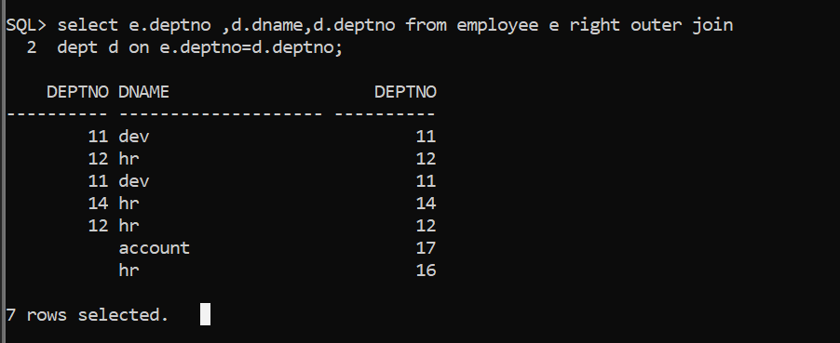

==================================================

**Full Join:-**

select e.deptno,d.deptno,d.dname from employee e full join

dept d on e.deptno=d.deptno;

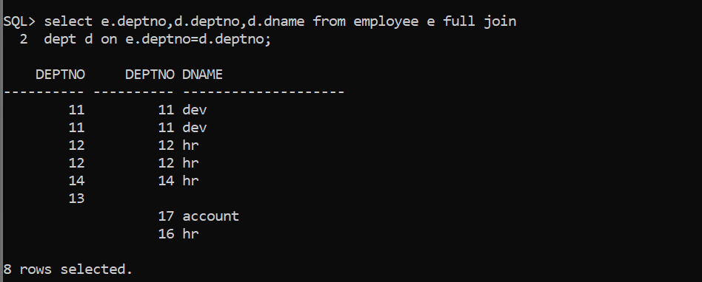

==================================================

**Self Join:-(Inner Join)**

select b.ename from employee a ,employee b where a.empno=102

and a.deptno=b.deptno;

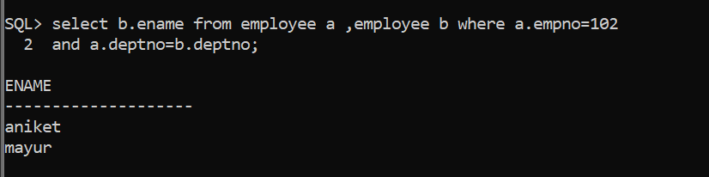

==================================================

**Cross Join:-**

select * from employee,dept;

==================================================

**Sub-Query:-**

Select * from employee where salary>(select avg(salary) from employee);

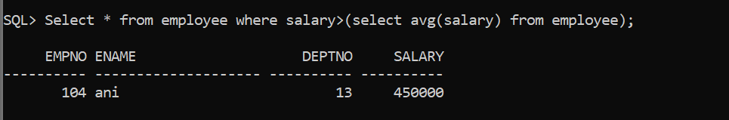

**Single-Row Sub-Queries or Corelated Queries:-** ‘ =’ use in query

select empno,ename from employee where deptno=(select deptno from dept where dname='dev');

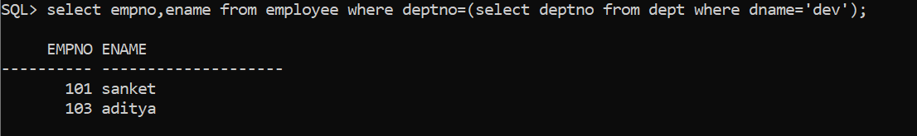

----------------------------------

**Multi-Row Sub-Queries:- in use here**

select ename from employee where deptno in(select deptno from dept);

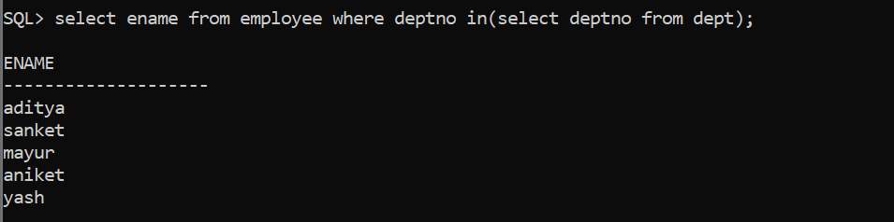

select ename,salary from employee where (deptno,salary)

in(select deptno,max(salary) from employee group by deptno);

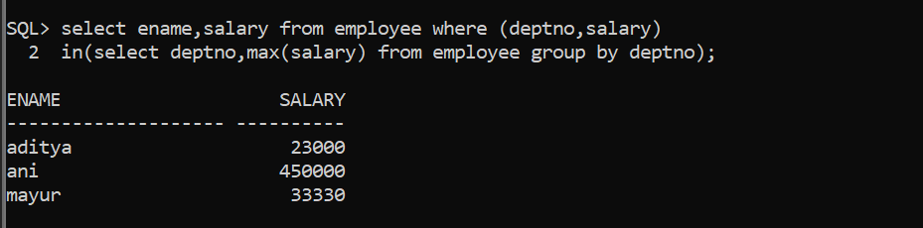

============================================================

**VIEW:-**

create or replace view v1

as select empno,ename,deptno,salary from employee;

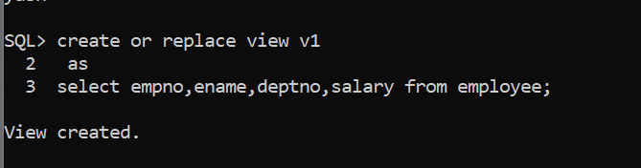

----------------------------------------------------------------------------

select * from v1 where empno between 101 and 104;

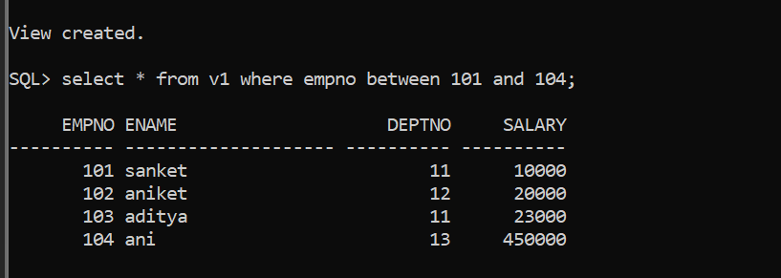

select * from v1 where empno=104;

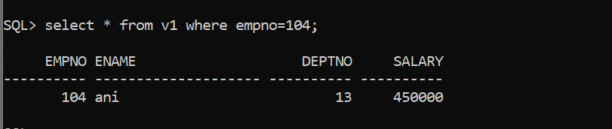

update v1 set ename='adi' where salary=23000;



